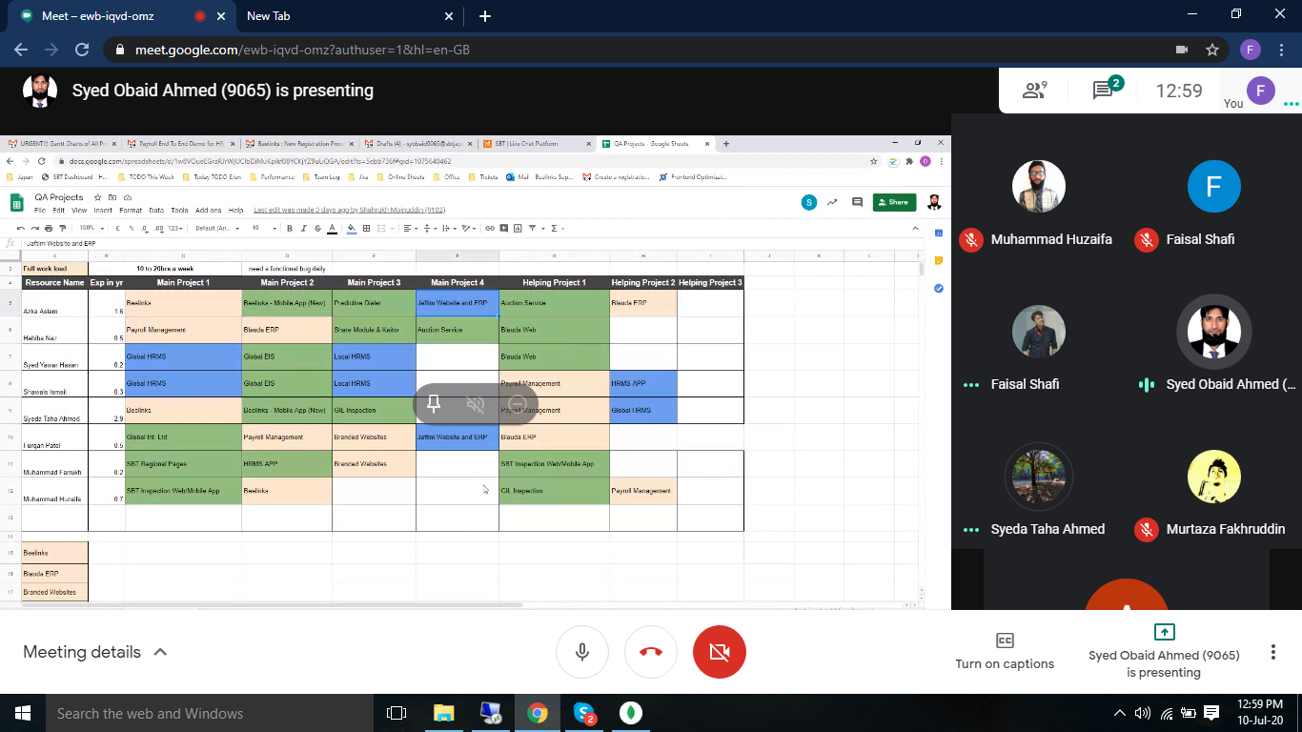

1. In Iconn registration API we need to push Source Name, Ticket No and Chat Id.  We need to tell Japan how they will use these IDs and where Pakistan wants to see these IDs in Iconn
2. Need Sales hierarchy API which includes who is the supervisor, which market is assigned.  Please discuss this point in the meeting and mention all the other columns you need in this API.
3. Need Customer Contact API which will response following. Please discuss this point in the meeting and mention all the other columns you need in this API.
   * Detail of the user who contacted the customer
   * When customer last contacted?
   * Customer last contacted phone number
   * How many times have customers contacted?
   * How long does the agent talk to the customer

POINTS:

\*client ID of ticket append with ->source: api

\*from ticket id, find chat id and append it

These fields required by api:

* CODE
* NAME
* EMAIL
* EXT
* POSITION
* STATUS
* OFFICE
* MAIN DEPARTMENT
* SUB-DEPARTMENT
* Immediate supervisor
* 3:20 PM
* Local Manager
* Country Manager
* Regional Manager
* General Manager
* Director
* Group Country
* Assigned market
* Active employee
* Resigned employee
* Business name

